How to link the program between 2 programs

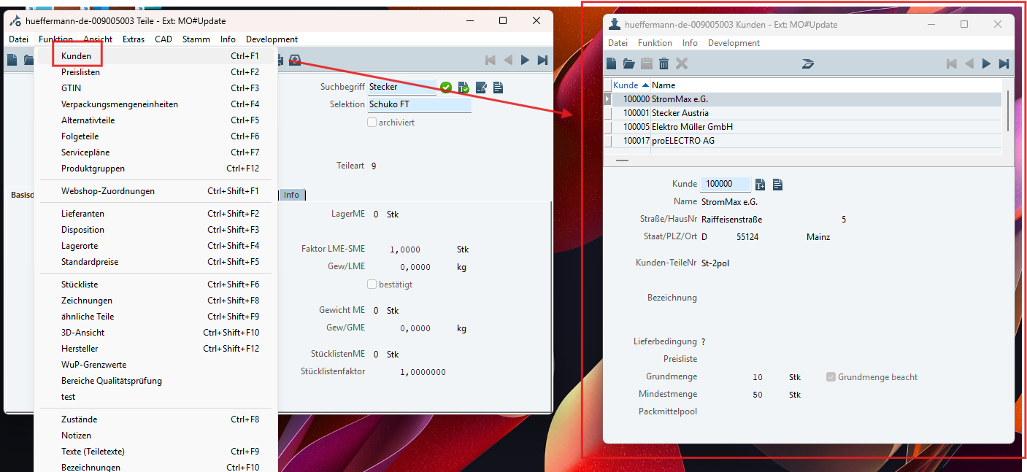
The programs can be linked together when they have related functionality. For example, when you click the Kunde menu in the Teile function, it means the programs are connected and have a relationship with each other. This relationship helps identify how many customers (Kunde) are related to a specific part.

How to do it?
- You need to create menu to link another program first.
- Check the supplied keys in the first page has been send it yet? If not, you need to send it as well.
- Open info window on Development at the first page and select the browser or query file to check the keys.
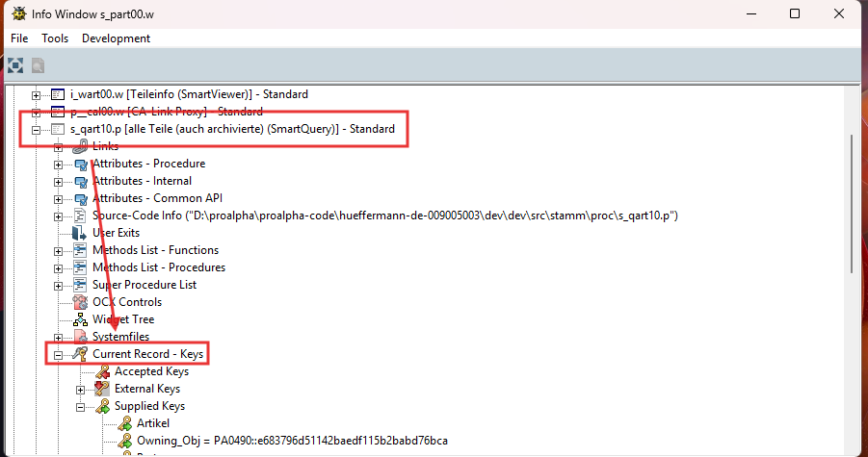
- Check on primary viewer that has been received the keys from query it yet. For send to another program.
- If not received the keys yet. You can go on the code of primary viewer such as s_wart00.w and find “set-attribute-list” and set the keys accepted or supplied of you want to use. (see example on s_wart00,01,02,03).
- Open the ab on the second program (container) such as s_paku10.w.
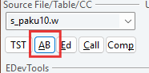

- On “AB” click “Smart Link”
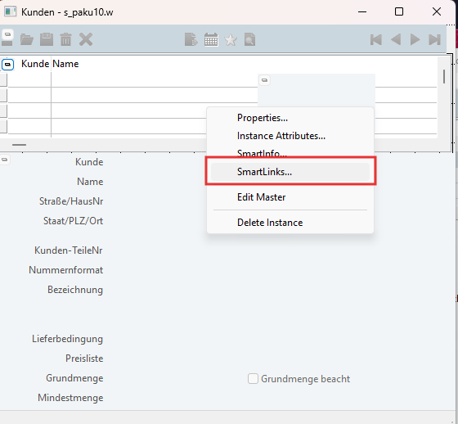
- Add this source to be connect to received the link from the first page.
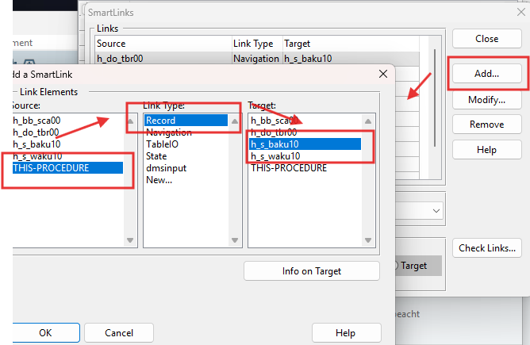

In condition you are found the bug. ( the supplied keys isn’t show on viewer).
- Open “AB” on file viewer and select the pencil.
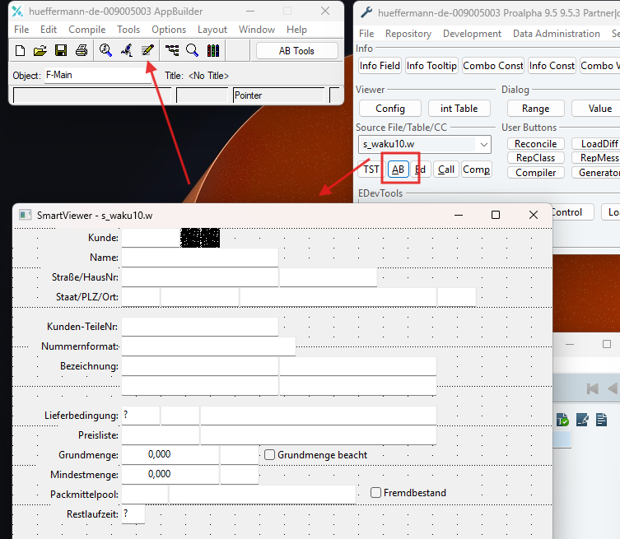
- Select the “Main Block” and select button “List”. And check the foreign keys.
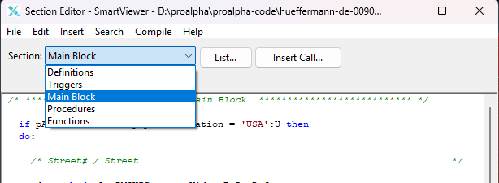
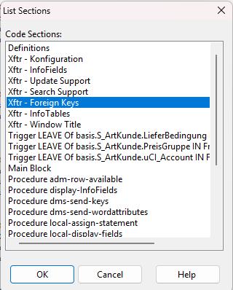
- You can check the keys and send the keys as you want in this here.
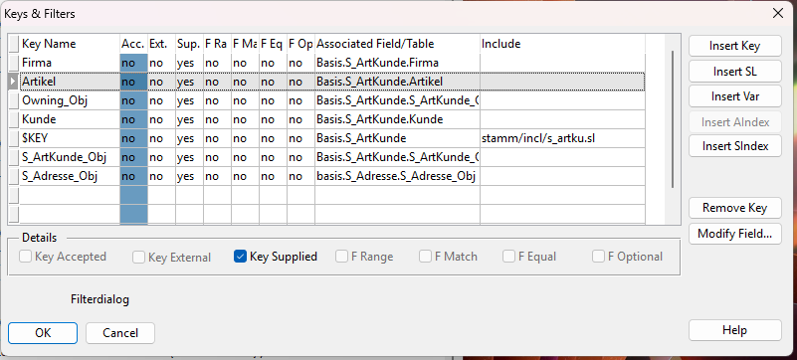

Another way:
- Go on your file viewer and find “set-attribute-list” and add your keys.
